Feldenkrais With Sally Low

Releasing and Relaxing Your Shoulders

Saturday 13th October 1pm – 4pm

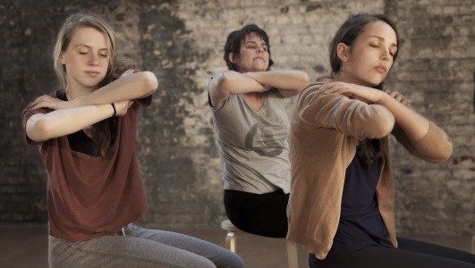

Tension in the shoulders is a common complaint, leading to restriction of breathing, neck pain, headaches and limited shoulder function. You will discover simple and effective ways to release and relax your shoulders. Through gentle Feldenkrais Awareness Through Movement Lessons and Sally’s extensive clinical experience, you will learn movement sequences and simple strategies to assist you in experiencing greater freedom in your shoulders.

This workshop is suitable for:
- Chronic shoulder and neck tension
- Headaches
- Restricted breathing and tightness in the chest
- Rotator cuff injuries
- Tennis and golfer’s elbow
- Frozen shoulders
- Anyone who wants to improve how they feel in their body and improve their flexibility, stability, strength and coordination in their shoulders.

Sally provides valuable knowledge from over 35 years as a physiotherapist and Feldenkrais Practitioner, which participants can benefit through this introductory workshop. You will gain insight into your habitual patterns and discover a pathway to enable improvement through awareness and embodiment.

Where: Dharma Circle Collective
3/569 Barkly St
West Footscray

Cost: $85
https://www.trybooking.com/YACL

For more information please contact Sally Low 0405170090
www.sallylowmethod.com

